

**COLLEGE OF ENGINEERING   
& BUILT ENVIRONMENT**



**Book Store Management Application**

**User Manual**

**DT080B**

**Report**

by

Student Name: **Maksymilian Drzezdzon**

Student Number: **C15311966**

Date: 04/23/2019

**USER MANUAL**

**1.0) General information………………………………………………………3**

**1.1) system overview…………………………………………………………………………………………………3**

**1.2) Manual Layout……………………………………………………………………………………………………3**

**2.0) System summary………………………………………………………….4**

**2.1) Application Behavior………………………………………………………………………………………….4**

**2.2) User Access levels………………………………………………………………………………………………4**

**3.0) Getting Started…………………………………………………………….5**

**1.0) GENERAL INFORMATION**

The following application is used to store, update, and retrieve information about books the store provides. It can also be used to remove, edit or add new customer details.

* 1. **System overview**

This application stores data about the stores stock and customer base, several features such as customer self-checkout and an online alternative are still underdevelopment.

**1.2)** **Manual Layout**

This user manual consists of 3 sections General Information, System Summary, Getting started, Using the application.

General Information 🡪 This section explains the purpose of the system.

System Summary 🡪 This section provides the general overview of the system, application behaviors and user access levels.

Getting started 🡪 This section provides an explanation for each implemented feature with a combination of examples and screen captures.

**2.0 SYSTEM SUMMARY**

System summary provides an overview of the application such as application behavior and user access levels.

**2**.**1 Application behavior**

This application can run on any operating system that supports java. It requires Microsoft access to be installed on the machine. an internet connection is not required as those features are not implemented yet.

In case of a power outage there is no guarantee that data will be retained.

**2.2) User Access Levels**

Any user can login and access the application, it is important to know that users can edit their records this is intentional. In a further release of the application additional support for this will be implemented where users will be able to use this mechanism as a self-checkout system in the store.

**3.0) Getting started**

This section goes over examples of the application in action.

OK so let’s get started!

You will be prompted with the following screen

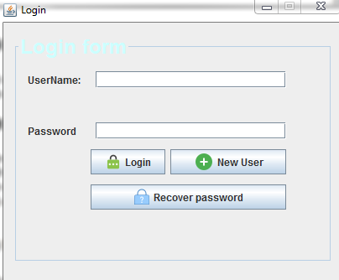

Here you can log in , add a new costumer ,person of staff etc or recover your password with a security question.

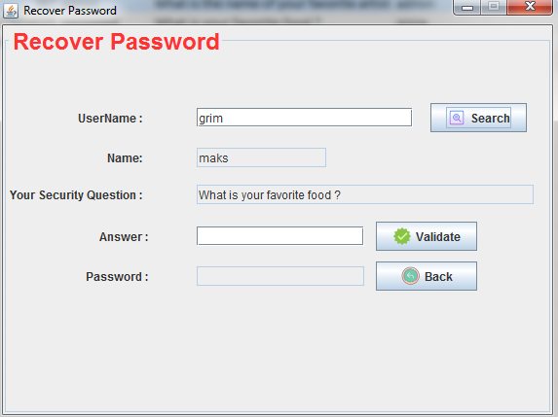

Here you can search for a user by their username to see that their account exists in the database. You will then be asked to provide an answer to the question which you can then validate and if it is correct you will be shown the password in plain text in the password field.

Adding a new customer

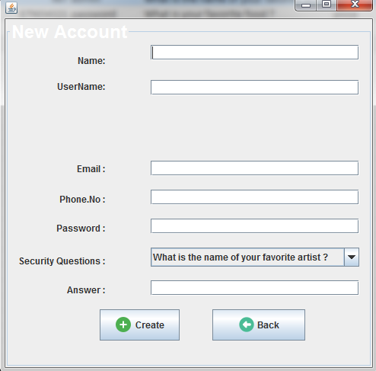

Here you need to fill out the fields accordingly and press create.

Upon successful login you will be prompted with the main home page which acts like a manager for all of your operations.

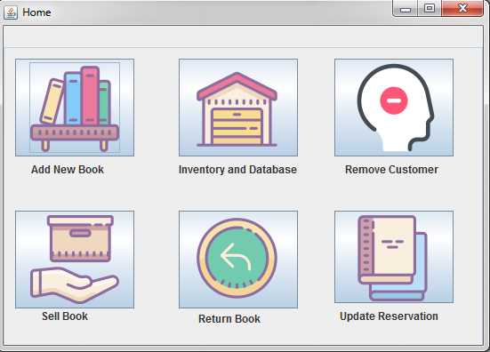

Adding a book prompts up a page similar to the one when creating an account, all you need to do is fill out the text boxes and that’s it! Press add after checking all information is correct.

The inventory tab retrieves information about different books that are in stock, item reservations that haven’t been claimed and users registered with the store

Removing a user follows the same pattern the rest of the functions do.

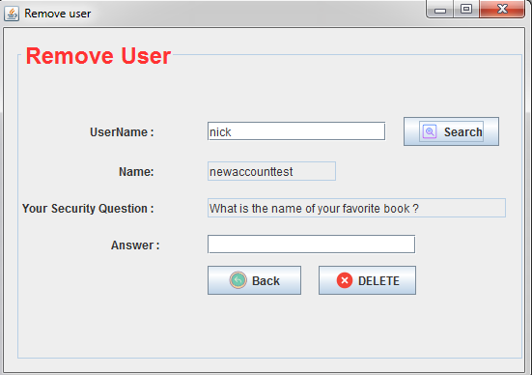

Simply fill out the text boxes provide any required information and press the associated button for the action to be executed.

In the sell book section, you need to provide the information for both the customer buying the book and ISBN of the book they are wishing to purchase, once this is done a simple click on the sell button will suffice.

If the book is not in stock currently, you can reserve it for a user and contact them when it is.

If you have an unhappy customer that wishes to return a book, no problem follow the same process as before and just press return book.

Last but not least , you can update the reservations and check any outstanding reservations, simply fill out the customer name and book they are looking to buy and press claim , this will remove the reservation from the database.

